

**WM. CALLBECK CENTRE**

**950 Callbeck Street, Central Bedeque,**

**Prince Edward Island, Canada**

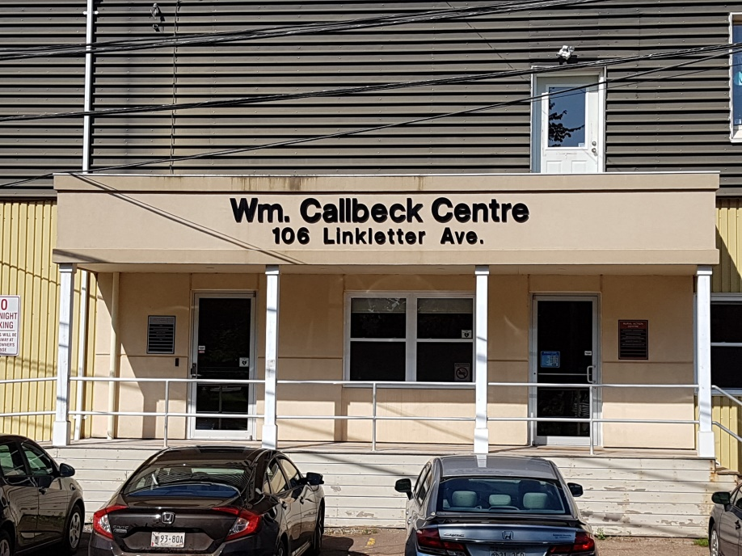

Rental Rate

Office - $10 - $12/SF + HST

Includes heat, garbage collection, insurance, parking, full time property maintenance.

Tenant responsible for electricity

Manufacturing - $5 -$5.50/SF + HST

FEATURES

Centrally Located in Prince Edward Island

12 km (7miles) from the Confederation Bridge in Borden-Carleton, 12 km (7miles) from Summerside and 45 km (28 miles) from Charlottetown.

Fully Renovated Facility

Dedicated high speed internet available, security access control system in place, common boardroom fully equipped and seats 30 and on-site Restaurant.

Building is fully wheel chair accessible.

AVAILABLE UNITS

Varying size units 209, 218, and 210



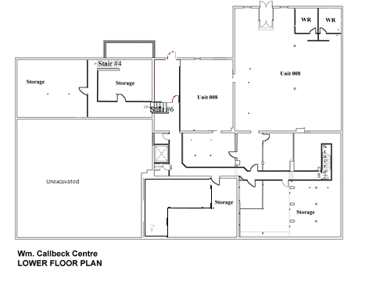

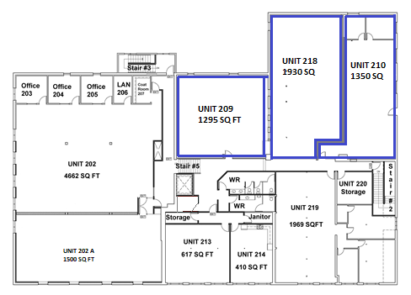

**Wm. Callbeck Centre**

**Second Floor Plan**

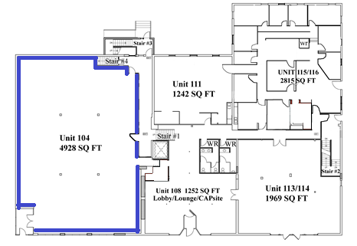

**Wm. Callbeck Centre**

**Main Floor Plan**

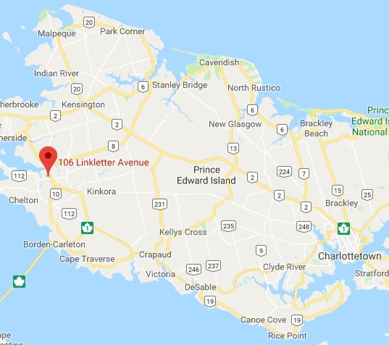

**Location**

**Site Photos**

